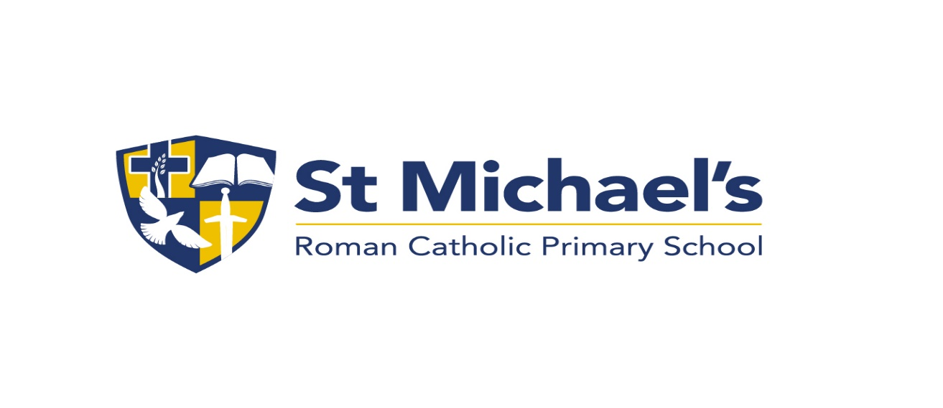

St Michael’s R.C. Primary School

Admissions Arrangements 2024
St. Michael’s is a Roman Catholic Primary School provided by the Diocese of Salford and is maintained by Bury Local Education Authority as a Voluntary Aided School. Admission to St. Michael's R.C. School Whitefield is the responsibility of the governors.

Admission to the school will be considered in the following order of priority if there are more applications for admission than the school has places available. The planned admission number is set at 30. Children who have been issued with an Education Health Care Plan will be offered a place at St. Michael’s if the school is named in the child’s care plan.

- Baptised Roman Catholic Looked After Children and baptised catholic previously Looked After Children.
- Baptised Roman Catholic children resident within the St. Michael’s parish catchment area with a sibling at St. Michael’s school at the time of admission.
- Baptised Roman Catholic children with a sibling at St. Michael’s at the time of admission and resident in the remaining part of St Michael’s and St Bernadette’s parish catchment area.
- Baptised Roman Catholic children resident within the St. Michael’s parish catchment area.
- Baptised Roman Catholic children resident in the remaining part of St Michael’s and St Bernadette’s parish catchment area.
- Baptised Roman Catholic children with a sibling at St. Michael’s at the time of admission and
resident in another parish.
- Baptised Roman Catholic children resident in another parish.
- Looked After Children and previously Looked After Children.
- Other children with a sibling attending the school at the time of admission.
- All remaining applicants.

Notes

- The closing date for admissions and the offer of a place is in line with the LA co-ordinated admissions arrangements. Applications received after the closing date will be treated as late applications. The governors will only accept applications received after this date if there is a genuine reason for doing so. Late applications will be considered after those applications received on time. Please note that from September 2010 all admissions are now dealt with by the LA on behalf of the governing body.

- Each Roman Catholic applicant will be required to produce a baptismal certificate and proof of residence.
- Parents need to ensure that they are resident in the parish of St. Michael’s and St Bernadette’s. If parents are not sure in which parish they reside they should contact school.

- It is the duty of governors to comply with the class size limits of Key Stage 1. This means that the school cannot operate classes in the Reception class and Key Stage 1 of more than 30 children.

- If there is over-subscription in any category, places will be offered using a straight line distance measurement from home to school. The distance will be measured using the Local Authority’s computerised mapping system, which measures from the address point of the home property to the address point of the school as defined by Bury Council’s LLPG (Local Land and Property Gazetteer). Those living closer on this basis will receive the higher priority.

- The school will hold a waiting list for the first term after the normal admission round, i.e. September to December. If places become available, they will be offered in accordance with the school’s admission policy.

- Where the admission criteria refers to ‘a brother or sister currently in school’ this means that the older
child will be attending the school at the time of admission of the younger child.

- If there is a situation where only one place is available and the next children to be offered are twins or triplets, both twins or the three triplets will be offered places

- For the purpose of admission a brother and sister includes step-brother and step-sister.
- Where a child has parents with shared responsibility and lives with each for part of the week, the home address will be decided by using the address to which the Child Benefit is paid.

- If an application for admission has been turned down by the Governing Body, parents can appeal to an independent Appeals Panel. This appeal must be sent in writing to the Clerk to the Governors at the school within 14 days of notification of a refusal. The parents must give their reasons for appealing in writing and the decision of the Appeals Panel is binding on the Governors.

Nursery

The nursery admission limit is set at 26 full-time equivalent places. Admission to the nursery will be considered with reference to the main school policy.

All children ages 3 and 4 are entitled to 15 hours free nursery childcare. We are able to offer the 5 free 3 hour sessions to meet the needs of the child.

Please note that a place in the school’s nursery does not guarantee a place in the school’s reception class.

